**Abstraction-**

It is the process of hiding the certain details and showing the important information to the end user called as “Abstraction”.

Hiding the internal implementation and just highlighting the set of services that we are providing to user is the concept of data abstraction.

Example- Real life scenario is car, ATM.

 

Example:

ATM GUI (Graphical User Interface) Screen.

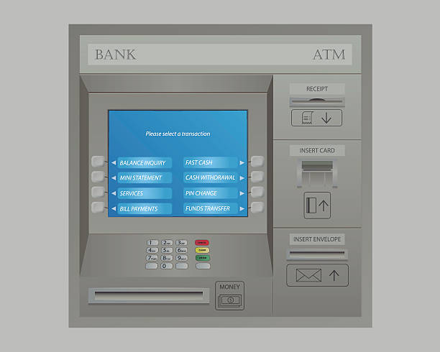

Fig. ATM GUI Screen

Above fig. represents ATM GUI screen. Here the set of services for the user are provided like Withdraw, Deposit, Check Balance & Mini Statement. But the internal implementation is hidden. As we don’t know internally which technology is used, in which language the code for this screen is written.

**Advantages:**

* Security to the code as no one knows internal implementation.
* We can change internal implementation without affecting user as they are not aware about internal implementation.

**How to achieve the Abstraction in java?**

There are two ways to achieve the abstraction in java.

1. Abstract class
2. Interface

**Abstract class**

A class which is declared with abstract keyword is known as abstract class. It is also known as incomplete class.

* Abstract class have constructor
* In abstract class we can achieve 0 to 100% abstraction.
* It contain abstract methods or concrete methods or empty class or combination of both methods.
* To use abstract method of class, we should extends the abstract class and use that methods.
* If we don't want to implement or override that method, make those methods as abstract.
* If any method is abstract in a class then that class must be declared as abstract
* We cannot create the object of abstract class.

Note-

Multiple inheritances are not allowed in abstract class but allowed in interfaces.

Abstract Method is nothing but method without body.

Example-

public class Test {

abstract void demo ();

}

Here, method is the abstract then class should be abstract only as per below example

public abstract class Test {

abstract void test();

void demo(){

//concrete methods here

}

**package** com.abstraction;

**public** **abstract** **class** Test {

**abstract** **void** example(); // abstract method

**abstract** **void** demo();

}

**How to implement that methods?**

We need to create the class which extends from abstract class as shown in below.

**package** com.abstraction;

**public** **class** C **extends** Test {

@Override

**void** example() {

System.***out***.println("this is the example method");

}

@Override

**void** demo() {

System.***out***.println("this is the demo method");

}

}

**package** com.abstraction;

**public** **class** TestMain {

**public** **static** **void** main(String[] args) {

C c= **new** C();

c.demo();

c.example();

}

}

Note-

Suppose in the sub class, I don’t want to override the abstract methods then make that subclass as abstract.

If we don’t create an object of abstract class then why do we need constructor inside abstract class?

Because, the constructor can be used to initialize the instance variables present in the abstract class.

**Interface-**

1. It contain public abstract methods and public static final variables by default.
2. We must follow I to C design principle in java. It means every class must be implemented by some interfaces.
3. In company, Team Lead or Manager level people can design the interface then give it to developer for implementing it.
4. We can not create the object of interface.
5. In interface, we can just define the method only but implemented those methods into implemented class.
6. Before 1.7, interface does not have any method body.
7. 1.8 Declare the default & static method with body in interface.
8. 1.9 we can define the private methods in interface also.
9. We cannot create the object of interface.
10. In interface, we can just define the method only but implemented that methods into implemented class.
11. Java supports multiple inheritance in the terms of interfaces but not classes.
12. Interface does not have constructor.

**Syntax**

interface interface_name {

}

Example-

**public** **interface** Demo {

**public** **abstract** **void** m1();

**public** **static** **final** **int** ***a***=5;

}

**Example**-

**package** com.abstra.interf;

**interface** A {

**public** **abstract** **void** demo();

**public** **abstract** **void** example();

}

interface A{

public abstract void demo (); //allowed

public void demo (); //allowed

void demo (); //allowed

abstract void demo (); //allowed

}

**Note-** if we don’t write public or abstract in interface then JVM will insert it automatically.

}

**package** com.abstra.interf;

**interface** A {

**public** **abstract** **void** demo();

**public** **abstract** **void** example();

}

**package** com.abstra.interf;

**public** **class** Z **implements** A {

@Override

**public** **void** demo() {

System.***out***.println("this is demo method");

}

@Override

**public** **void** example() {

System.***out***.println("this is example method");

}

}

**package** com.abstra.interf;

**public** **class** TestMain {

**public** **static** **void** main(String[] args) {

Z z = **new** Z();

z.demo();

z.example();

//A a= new A();

}

}

Example-2

interface A {

}

interface B {

}

Interface C extends A, B {

}

This is allowed in java.

Below are the list of possible scenario regarding the interface and

Note- Try this from your end on laptop or desktop.

* interface can extend interface1 and interface2
* Interface can extends interface
* Interface can extends the multiple interface
* class extends class implements interface
* class implements interface
* class extends class implements interface1 and interface2

**Why interface?**

Suppose there is a requirement for Amazon to integrate SBI bank code into their shopping cart. Their customers want to make payment for products they purchased.

Let's say SBI develops code like below:

class Transaction {

void withdrawAmt(int amtToWithdraw) {

//logic of withdraw

// SBI DB connection and updating in their DB

}

}

Amazon needs this class so they request SBI bank for the same. The problem with SBI is that if they give this complete code to amazon they risk exposing everything of their own database to them as well as their logic, which cause a security violation.

Now the solution is for SBI to develop an Interface of Transaction class as shown below:

interface Transactioni {

void withdrawAmt(int amtToWithdraw) ;

}

class TransactionImpl implements Transactioni {

void withdrawAmt(int amtToWithdraw) {

//logic of withdraw

//SBI DB connection and updating in their DB

}

}

Now how amazon will do this as below as-

Transactioni ti = new TransactionImpl();

ti.withdrawAmt(500);

In this case, both application can achieve their aims.

**Difference between Interface & Abstract class**

|  |  |
| --- | --- |
| Interface | Abstract class |
| If we don’t know anything about implementation & we just have requirement specification then we should go for the interface. | If we are talking about implementation but not completely (partial implementation) then we should go for the abstract class. |
| Inside interface every method is  always public & abstract hence it is  also considered as 100% pure  abstract class. | Inside Abstract class, every method  need not to be public & abstract. We  can have concrete method also in  abstract class. |
| 100% abstraction level can be  achieved. | 0 to 100% abstraction level can be  achieved. |
| We can’t declare the interface  method with following modifiers  Private, protected, final. Static. It  gives compile time error. | There are no restrictions on  modifiers in the case of abstract  class methods. |
| Every variable inside interface is  always public static final. | Variable present is abstract class  need not to be public static final. |
| We can’t declare the variables with  private & protected modifiers in  case of interface. | There is no restriction on variable  in case of abstract class. |
| For the interface variables compulsorily, we should perform initialization at the time of declaration otherwise it will give  compile time error. | Here abstract class variables don’t  require initialization at the time of  declaration. |
| Inside interface we can’t declare  instance blocks & static blocks. | We can declare instance blocks &  static blocks in case of abstract  class. |
| Inside interface we can’t declare  constructors. | Inside Abstract class we can declare constructor which will be executed  or called at the time of child object  creation. |